**Git and GitHub Crash Course**

**Tools**

* VS Code
* Git Bas

Create Name and Output Name

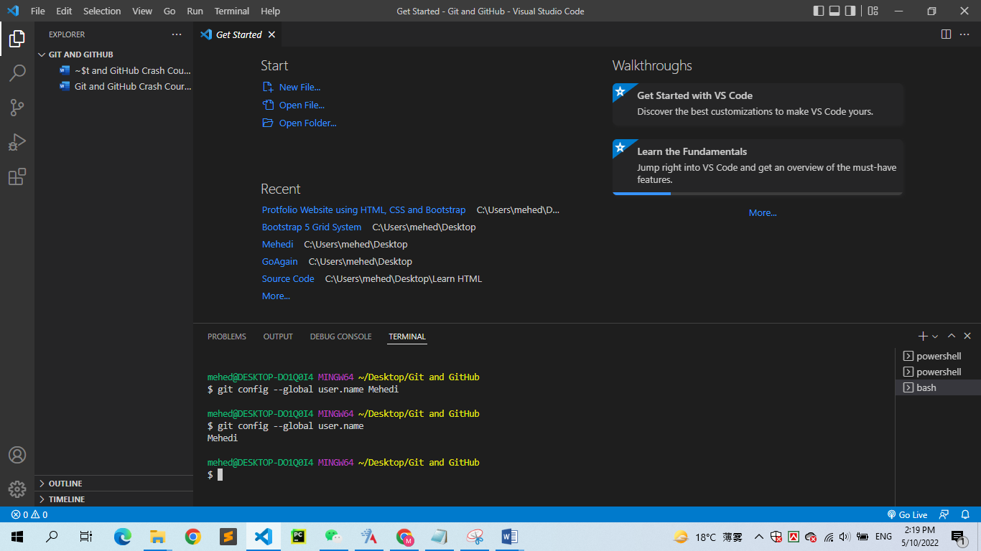

Add Email address in terminal

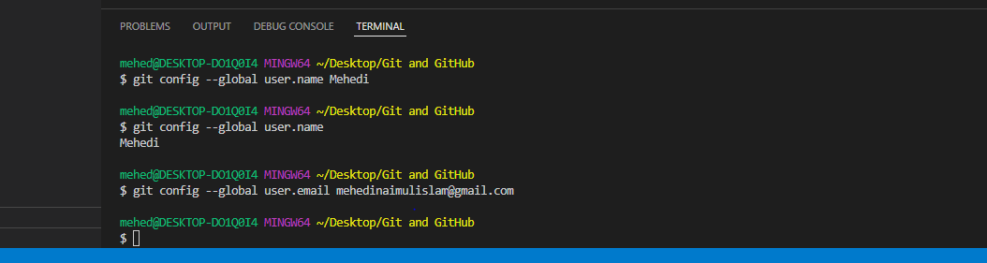

Get admin’s email address

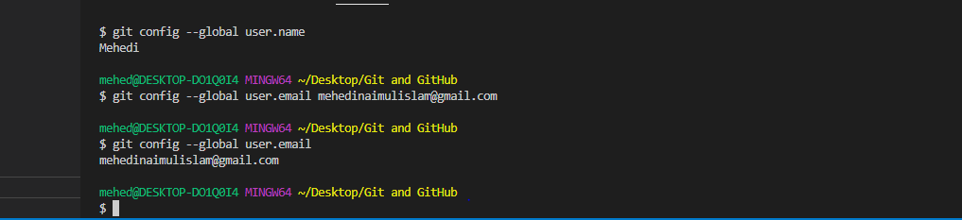

Clear Terminal

mehed@DESKTOP-DO1Q0I4 MINGW64 ~/Desktop/Git and GitHub

$ Clear

**init Command**

**Active Git and Check Blank Folder**

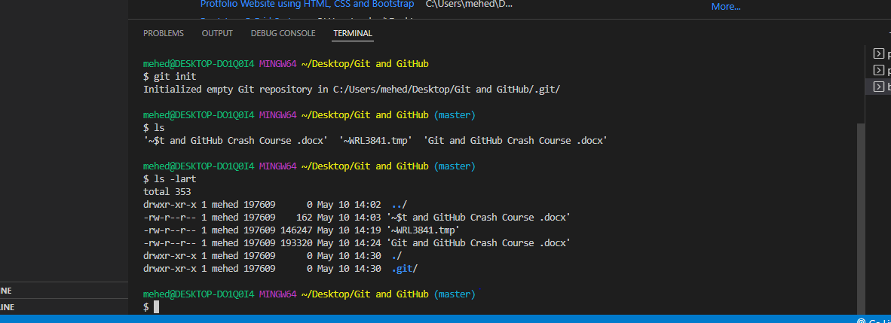

Create new file in folder with git

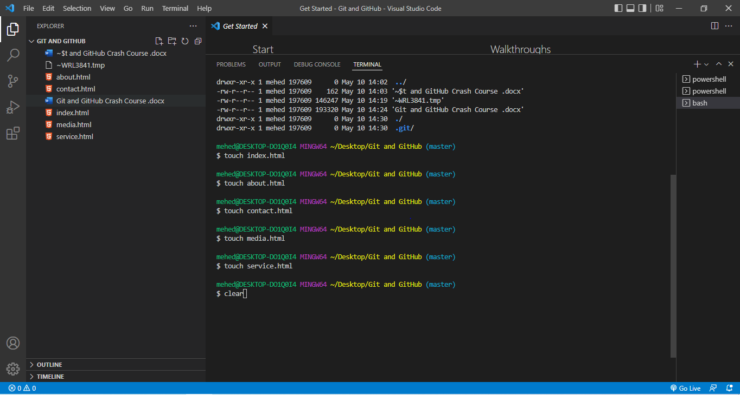

**Check git Status**

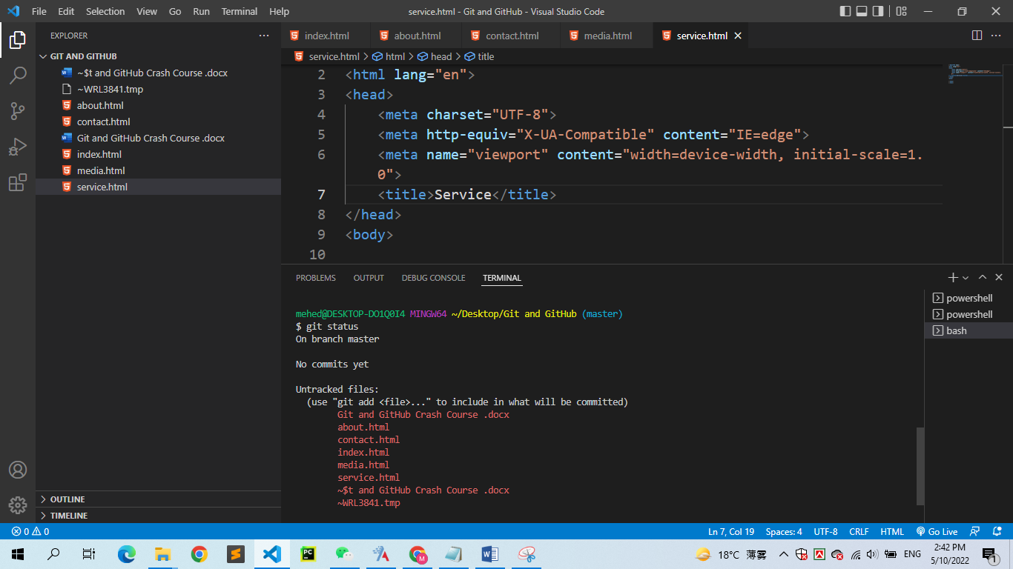

Staged File

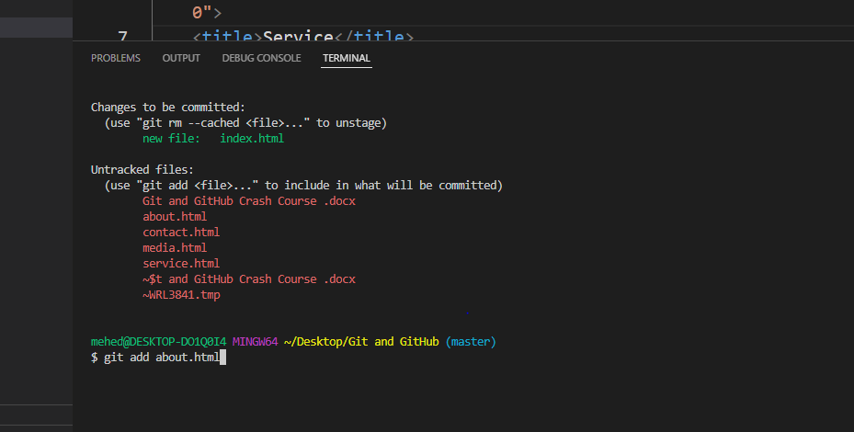

Stage All File

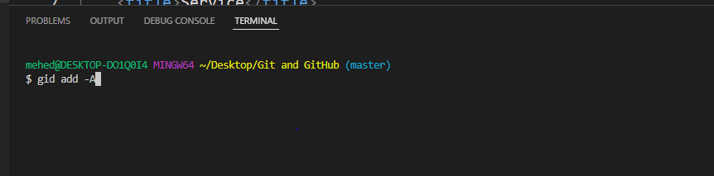

Check File

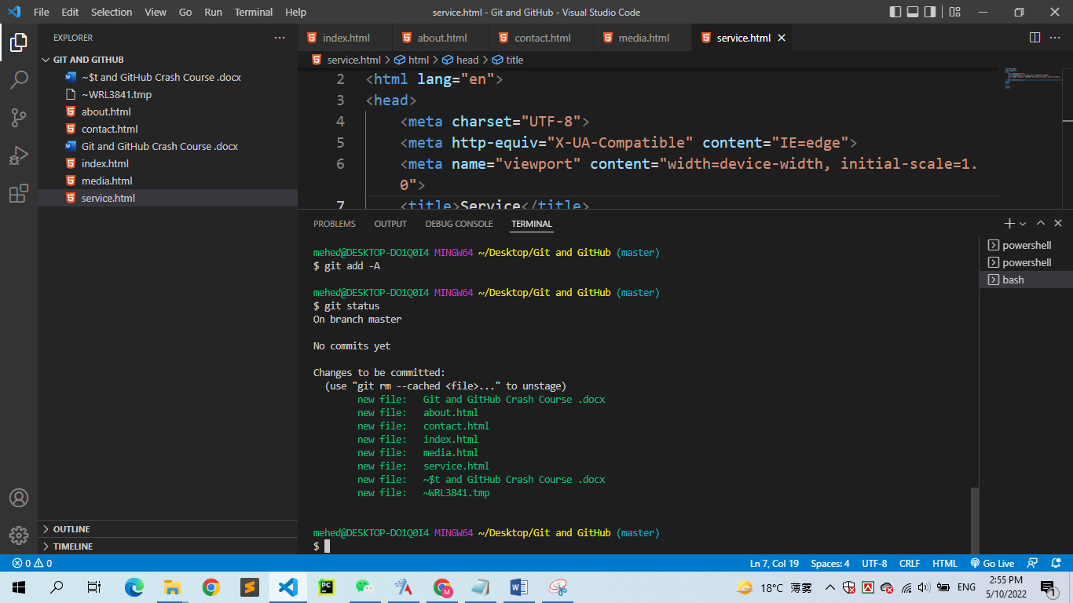

For Reset

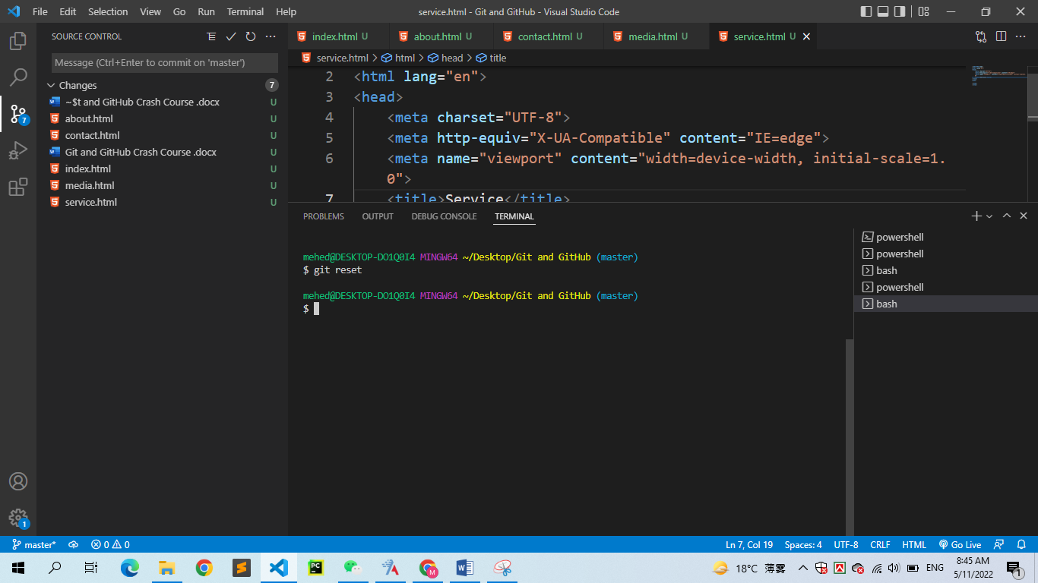

Put stage a folder

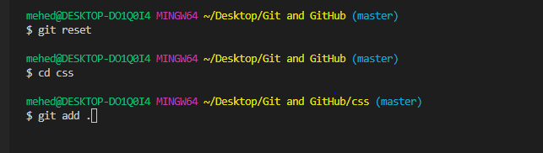

Check git status

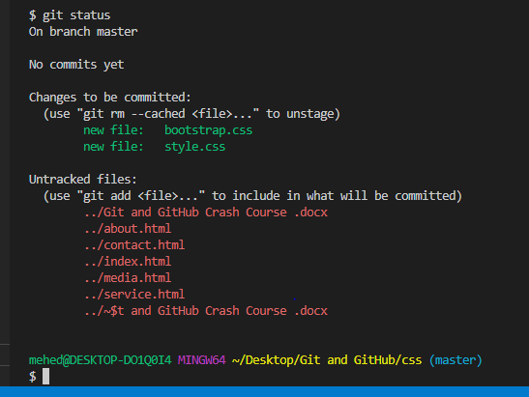

Put stage a specific file from folder

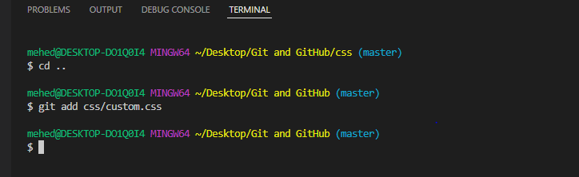

Git Commit

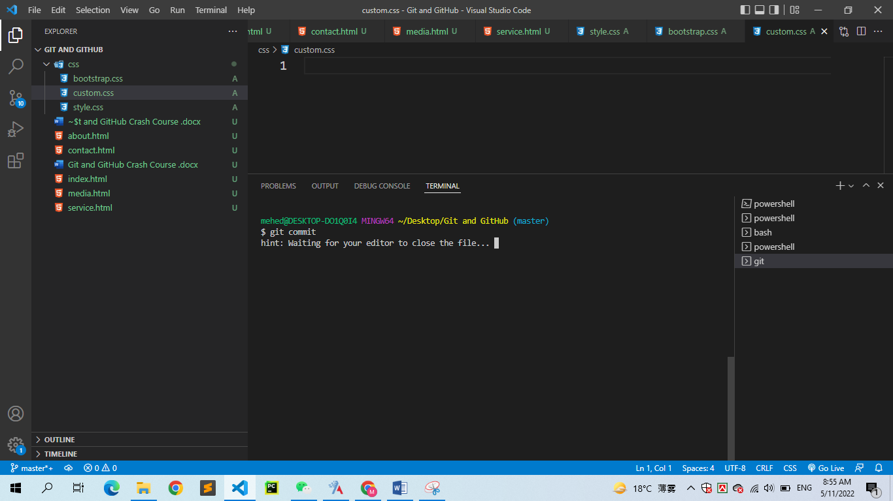

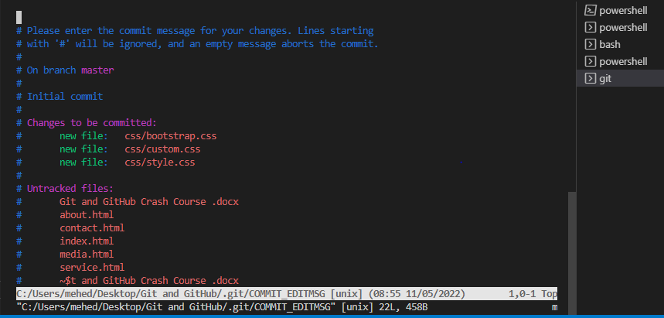

Add everything

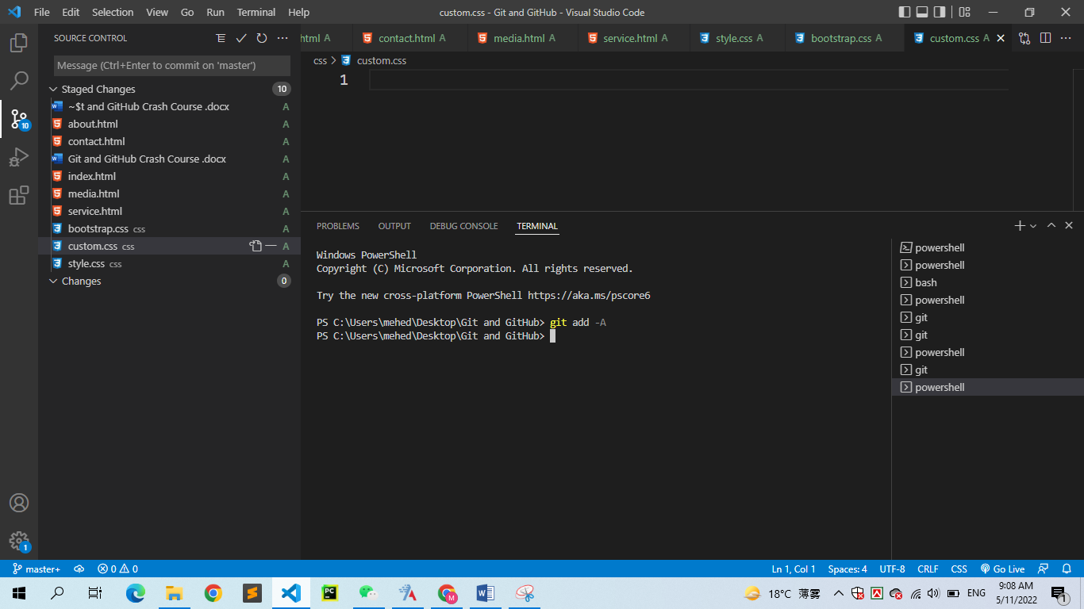

Git commit

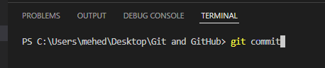

**Merge Branches**

We have the emergency fix ready, and so let’s merge the master and emergency-fix branches.

First， we need to change to the master branch:

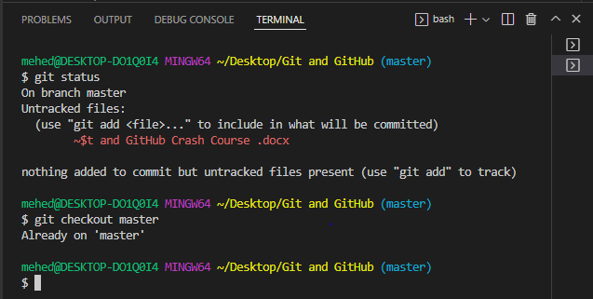

Now we merge the current branch (master) with emergency-fix:

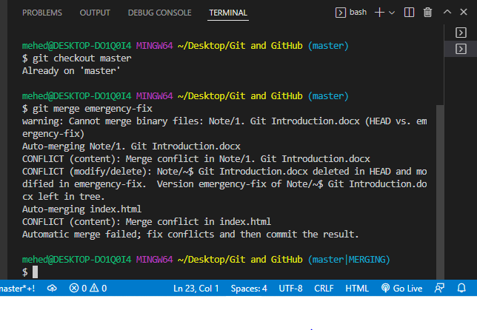

Since the emergency-fix branch came directly from master, and no other changes had been made to master while we were working, Git sees this as a continuation of master. So it can “Fast-forward”,